Formatted Input

It refers to an input data which has been arranged in a specific format. This is possible in C using scanf(). We have already encountered this and familiar with this function.
scanf("control string", arg1, arg2, ..., argn);
The field specification for reading integer inputted number is:
%w sd
Here the % sign denotes the conversion specification; w signifies the integer number that defines the field width of the number to be read. d defines the number to be read in integer format.
#include<stdio.h>

void main()
{
int var1= 60;
int var2= 1234;
scanf("%2d %5d", &var1, &var2);
}
Input data items should have to be separated by spaces, tabs or new-line and the punctuation marks are not counted as separators.

Format Specifier Used In printf () Function
A general form of format specifier is
%[flags][width][.precision][length]specifier
Given below is a description of each of the parts of format specifier:
- % sign: This is a leading % sign
- Flags: They can have the following values:
  - –: Left justifies the result within the field. By default, right justified.
  - +: The sign of the result attached to the beginning of the value including positive results.
  - Space: In the absence of a sign, space is attached to the beginning of the result.
  - #: Specify an alternative form of conversion.
  - 0: Used for integer and floating-point numbers. Act as leading zeros in the absence of space.
- Width: Specifies minimum field width in the form of a * or an integer value. This is optional.
- Precision: Specifies precision with a ‘.’ followed by a * or an integer or nothing. This is also optional.
- Length: The optional argument that specified the size of the argument.
- Specifier: This is a conversion format specifier.
Various Format Specifiers used in C++ are as follows:
No | Specifier | Description
1 | % | Prints a %.
2 | C | Prints single character.
3 | S | Prints a string.
4 | d/i | Converts signed integer to decimal representation.
5 | O | Converts unsigned integer to octal representation.
6 | x/X | Converts unsigned integer to hexadecimal representation.
7 | U | Converts unsigned integer to decimal representation.
8 | f/F | Converts floating-point number to decimal representation.
9 | e/E | Converts floating-point number to decimal exponent notation.
10 | a/A | Converts floating-point number to a hexadecimal exponent.
11 | g/G | Converts floating-point number to decimal or decimal exponent notation.
12 | N | Number of characters written so far by this function call.
13 | P | A pointer pointing to Implementation defined character sequence.
Given below is a complete C++ programming example that demonstrates the printf function discussed above.

C++ printf Example
#include <cstdio>
//C++ printf example
int main()
{
char ch = 'A';
float a = 8.0, b = 3.0;
double d = 3.142;
int x = 20;
printf("float division : %.3f / %.3f = %.3f \n", a,b,a/b);
printf("Double value: %.4f \n", d);
printf("Setting width %*c \n",4,ch);
printf("Octal equivalent of %d is %o \n",x,x);
printf("Hex equivalent of %d is %x \n",x,x);
return 0;
}
Output:
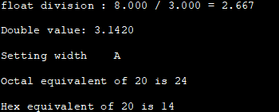

Format Specifier Used In scanf() Function
The general format for the scanf () function format string is:
%[*][width][length]specifier
Thus the format specifier has the following parts:
- Non-whitespace character: These are the characters except % that consume one identical character from the input stream.
- Whitespace character: All consecutive whitespace characters are considered as one whitespace character. The same goes for escape sequences too.
- Conversion specification: It has the following format:
  - %: Character that specifies the beginning.
  - *: Called assignment suppressing character. If present, the scanf does not assign the result to any receiving parameters. This parameter is optional.
  - Field width: Optional parameter (a positive integer) that specifies a maximum field width.
  - Length: Specifies the size of receiving an argument.
Conversion Format Specifier can be as follows:
No | Format specifier | Description
1 | % | Matches literal %.
2 | C | Matches single character or multiple characters up to width.
3 | S | Matches sequence of non-whitespace character until specified width or first whitespace.
4 | D | Matches decimal.
5 | I | Matches integer.
6 | O | Matches unsigned octal integer.
7 | x/X | Matches unsigned hexadecimal integer.
8 | U | Matches unsigned decimal integer.
9 | a/A, e/E,f/F, g/G | Matches floating-point number.
10 | [set] | Matches non-.empty sequence of characters from the given set. If preceded by ^, then characters not in set are matched.
12 | N | Returns number of characters read so far.
13 | P | Pointer to implementation specific character sequence.
Next, we will implement a sample program to demonstrate the usage of scanf function in C++

scanf Example
#include <cstdio>
int main ()
{
char str [80], pos_str[80];
int i;
printf ("Enter your company name: ");
scanf ("%79s",str);
printf ("Enter your position: ");
scanf ("%s",pos_str);
printf ("You work at %s as %s.\n",str,pos_str);
printf ("Enter a hexadecimal number: ");
scanf ("%x",&i);
printf ("You have entered %#x (%d).\n",i,i);

return 0;
}
Output:
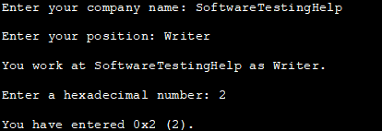
In the above program, we read two input strings and a hexadecimal number. Then we combine the two strings and display the resultant string. The number is converted to decimal and displayed.

Format specifiers in C
The format specifier is used during input and output. It is a way to tell the compiler what type of data is in a variable during taking input using scanf() or printing using printf(). Some examples are %c, %d, %f, etc.
The format specifier in printf() and scanf() are mostly the same but there is some difference which we will see.

printf(char *format, arg1, arg2, …)
This function prints the character on standard output and returns the number of character printed the format is a string starting with % and ends with conversion character (like c, i, f, d, etc.).
Between both, there can be elements governing the printing format. Below is its description
- A minus(-) sign tells left alignment.
- A number after % specifies the minimum field width to be printed if the characters are less than the size of width the remaining space is filled with space and if it is greater than it printed as it is without truncation.
- A period( . ) symbol separate field width with the precision.
Precision tells the maximum number of digits in integer, characters in string and number of digits after decimal part in floating value.
Lets see these..
Character format specifier : %c

C
#include <stdio.h>
int main()
{
char ch = 'A';
printf("%c\n", ch);
return 0;
}
Output:
A

For Signed Integer format specifier : %d, %i

C
#include <stdio.h>
int main()
{
int x = 45, y = 90;
printf("%d\n", x);
printf("%i\n", x);
return 0;
}
Output:
45
45

Unsigned Integer Format Specifier: %u:

C
#include <stdio.h>
int main()
{
// The -10 value is converted into it's positive
// equivalent by %u
printf("%u\n", -10);
printf("%u\n", 10);
return 0;
}
Output: 4294967286
10
Floating-point format specifier : %f, %e or %E

C
#include <stdio.h>
int main()
{
float a = 12.67;
printf("%f\n", a);
printf("%e\n", a);
return 0;
}
Output:
12.670000
1.267000e+01

Unsigned Octal number for integer : %o

C
#include <stdio.h>
int main()
{
int a = 67;
printf("%o\n", a);
return 0;
}
Output:
103

Unsigned Hexadecimal for integer: %x, %X

C
#include <stdio.h>
int main()
{
int a = 15;
printf("%x\n", a);
return 0;
}
Output:

f

String printing: %s

C
#include <stdio.h>
int main()
{
char a[] = "geeksforgeeks";
printf("%s\n", a);
return 0;
}
Output:
geeksforgeeks

Address Printing: %p
When our intention is to print the memory address of a variable/pointer ‘%d’ will not work because ‘%d’ will try to format an address into a number and values like 0xbfdd812 is clearly not a number, ie we MUST use %p.

C
#include <stdio.h>
int main()
{
int a = 10;
printf("The Memory Address of a: %p\n",(void*)&a);
return 0;
}
Output: The Memory Address of a: 0x7ffc85861624

More formatting

C
#include <stdio.h>
int main()
{
char str[] = "geeksforgeeks";
printf("%20s\n", str);
printf("%-20s\n", str);
printf("%20.5s\n", str);
printf("%-20.5s\n", str);
return 0;
}
Output:
geeksforgeeks
geeksforgeeks
geeks
geeks

scanf(char *format, arg1, arg2, …)
This function take input using standard input (keyboard) and store it in variable accordingly. It returns the number of items successfully read. Formal parameter arg1, agr2, .. must be a pointer
decimal integer : %d

C
#include <stdio.h>
int main()
{
int a = 0;
scanf("%d", &a); // input is 45
printf("%d\n", a);
return 0;
}
Integer may be octal or in hexadecimal : %i

C
#include <stdio.h>
int main()
{
int a = 0;
scanf("%i", &a); // input is 017 (octal of 15 )
printf("%d\n", a);
scanf("%i", &a); // input is 0xf (hexadecimal of 15 )
printf("%d\n", a);
return 0;
}
Double floating-point number : %lf

C
#include <stdio.h>
int main()
{
double a = 0.0;
scanf("%lf", &a); // input is 45.65
printf("%lf\n", a);
return 0;
}
Output:
45.650000

String input : %s

C
#include <stdio.h>
int main()
{
char str[20];
scanf("%s", str); // input is geeksforgeeks
printf("%s\n", str);
return 0;
}
Output:
P@

Character input : %c

C
#include <stdio.h>
int main()
{
char ch;
scanf("%c", &ch); // input is A
printf("%c\n", ch);
return 0;
}
Many other format specifiers are also there
1.%u for an unsigned integer.
2.%lld for long long int.
3.%o octal integer without leading zero
4.%x hexadecimal integer without 0x before the number.

FILE
So far the operations using C program are done on a prompt / terminal which is not stored anywhere. But in the software industry, most of the programs are written to store the information fetched from the program. One such way is to store the fetched information in a file. Different operations that can be performed on a file are:
- Creation of a new file (fopen with attributes as “a” or “a+” or “w” or “w++”)
- Opening an existing file (fopen)
- Reading from file (fscanf or fgets)
- Writing to a file (fprintf or fputs)
- Moving to a specific location in a file (fseek, rewind)
- Closing a file (fclose)
The text in the brackets denotes the functions used for performing those operations.
Functions in File Operations:
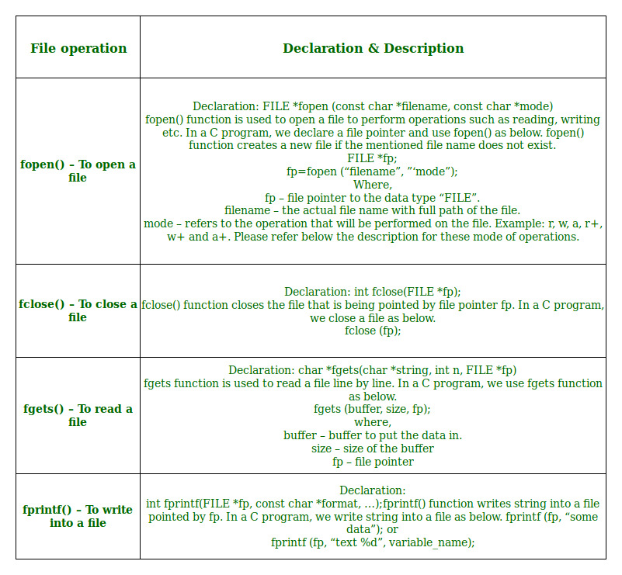
Opening or creating file
For opening a file, fopen function is used with the required access modes. Some of the commonly used file access modes are mentioned below.
File opening modes in C:

- “r” – Searches file. If the file is opened successfully fopen( ) loads it into memory and sets up a pointer which points to the first character in it. If the file cannot be opened fopen( ) returns NULL.
- “w” – Searches file. If the file exists, its contents are overwritten. If the file doesn’t exist, a new file is created. Returns NULL, if unable to open file.
- “a” – Searches file. If the file is opened successfully fopen( ) loads it into memory and sets up a pointer that points to the last character in it. If the file doesn’t exist, a new file is created. Returns NULL, if unable to open file.
- “r+” – Searches file. If is opened successfully fopen( ) loads it into memory and sets up a pointer which points to the first character in it. Returns NULL, if unable to open the file.
- “w+” – Searches file. If the file exists, its contents are overwritten. If the file doesn’t exist a new file is created. Returns NULL, if unable to open file.
- “a+” – Searches file. If the file is opened successfully fopen( ) loads it into memory and sets up a pointer which points to the last character in it. If the file doesn’t exist, a new file is created. Returns NULL, if unable to open file.
As given above, if you want to perform operations on a binary file, then you have to append ‘b’ at the last. For example, instead of “w”, you have to use “wb”, instead of “a+” you have to use “a+b”. For performing the operations on the file, a special pointer called File pointer is used which is declared as
FILE *filePointer;
So, the file can be opened as
filePointer = fopen(“fileName.txt”, “w”)
The second parameter can be changed to contain all the attributes listed in the above table.
- Reading from a file –
The file read operations can be performed using functions fscanf or fgets. Both the functions performed the same operations as that of scanf and gets but with an additional parameter, the file pointer. So, it depends on you if you want to read the file line by line or character by character.
And the code snippet for reading a file is as:
FILE * filePointer;
filePointer = fopen(“fileName.txt”, “r”);
fscanf(filePointer, "%s %s %s %d", str1, str2, str3, &year);
- Writing a file –:
The file write operations can be perfomed by the functions fprintf and fputs with similarities to read operations. The snippet for writing to a file is as :
FILE *filePointer ;
filePointer = fopen(“fileName.txt”, “w”);
fprintf(filePointer, "%s %s %s %d", "We", "are", "in", 2012);
- Closing a file –:
After every successful fie operations, you must always close a file. For closing a file, you have to use fclose function. The snippet for closing a file is given as :
- FILE *filePointer ;
- filePointer= fopen(“fileName.txt”, “w”);
- ---------- Some file Operations -------
fclose(filePointer)

Following are the most important file management functions available in 'C,'
function | purpose
fopen () | Creating a file or opening an existing file
fclose () | Closing a file
fprintf () | Writing a block of data to a file
fscanf () | Reading a block data from a file
getc () | Reads a single character from a file
putc () | Writes a single character to a file
getw () | Reads an integer from a file
putw () | Writing an integer to a file
fseek () | Sets the position of a file pointer to a specified location
ftell () | Returns the current position of a file pointer
rewind () | Sets the file pointer at the beginning of a file
In this tutorial, you will learn-
- How to Create a File
- How to Close a file:
- Writing to a File
  - fputc() Function:
  - fputs () Function:
  - fprintf()Function:
- Reading data from a File
- Interactive File Read and Write with getc and putc

How to Create a File
Whenever you want to work with a file, the first step is to create a file. A file is nothing but space in a memory where data is stored.
To create a file in a 'C' program following syntax is used,
FILE *fp;
fp = fopen ("file_name", "mode");
In the above syntax, the file is a data structure which is defined in the standard library.
fopen is a standard function which is used to open a file.
- If the file is not present on the system, then it is created and then opened.
- If a file is already present on the system, then it is directly opened using this function.
fp is a file pointer which points to the type file.
Whenever you open or create a file, you have to specify what you are going to do with the file. A file in 'C' programming can be created or opened for reading/writing purposes. A mode is used to specify whether you want to open a file for any of the below-given purposes. Following are the different types of modes in 'C' programming which can be used while working with a file.
File Mode | Description
r | Open a file for reading. If a file is in reading mode, then no data is deleted if a file is already present on a system.
w | Open a file for writing. If a file is in writing mode, then a new file is created if a file doesn't exist at all. If a file is already present on a system, then all the data inside the file is truncated, and it is opened for writing purposes.
a | Open a file in append mode. If a file is in append mode, then the file is opened. The content within the file doesn't change.
r+ | open for reading and writing from beginning
w+ | open for reading and writing, overwriting a file
a+ | open for reading and writing, appending to file
In the given syntax, the filename and the mode are specified as strings hence they must always be enclosed within double quotes.
Example:
#include <stdio.h>
int main() {
FILE *fp;
fp = fopen ("data.txt", "w");
}
Output:
File is created in the same folder where you have saved your code.
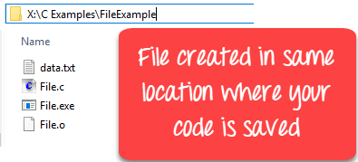
You can specify the path where you want to create your file
#include <stdio.h>
int main() {
FILE *fp;
fp = fopen ("D://data.txt", "w");
}
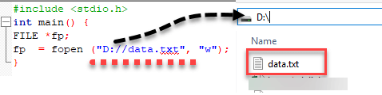

How to Close a file
One should always close a file whenever the operations on file are over. It means the contents and links to the file are terminated. This prevents accidental damage to the file.
'C' provides the fclose function to perform file closing operation. The syntax of fclose is as follows,
fclose (file_pointer);
Example:
FILE *fp;
fp = fopen ("data.txt", "r");
fclose (fp);
The fclose function takes a file pointer as an argument. The file associated with the file pointer is then closed with the help of fclose function. It returns 0 if close was successful and EOF (end of file) if there is an error has occurred while file closing.
After closing the file, the same file pointer can also be used with other files.
In 'C' programming, files are automatically close when the program is terminated. Closing a file manually by writing fclose function is a good programming practice.

Writing to a File
In C, when you write to a file, newline characters '\n' must be explicitly added.
The stdio library offers the necessary functions to write to a file:
- fputc(char, file_pointer): It writes a character to the file pointed to by file_pointer.
- fputs(str, file_pointer): It writes a string to the file pointed to by file_pointer.
- fprintf(file_pointer, str, variable_lists): It prints a string to the file pointed to by file_pointer. The string can optionally include format specifiers and a list of variables variable_lists.
The program below shows how to perform writing to a file:

fputc() Function:
#include <stdio.h>
int main() {
int i;
FILE * fptr;
char fn[50];
char str[] = "Guru99 Rocks\n";
fptr = fopen("fputc_test.txt", "w"); // "w" defines "writing mode"
for (i = 0; str[i] != '\n'; i++) {
/* write to file using fputc() function */
fputc(str[i], fptr);
}
fclose(fptr);
return 0;
}
Output:
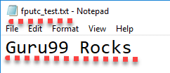
The above program writes a single character into the fputc_test.txt file until it reaches the next line symbol "\n" which indicates that the sentence was successfully written. The process is to take each character of the array and write it into the file.
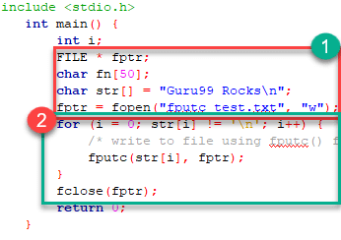
- In the above program, we have created and opened a file called fputc_test.txt in a write mode and declare our string which will be written into the file.
- We do a character by character write operation using for loop and put each character in our file until the "\n" character is encountered then the file is closed using the fclose function.

fputs () Function:
#include <stdio.h>
int main() {
FILE * fp;
fp = fopen("fputs_test.txt", "w+");
fputs("This is Guru99 Tutorial on fputs,", fp);
fputs("We don't need to use for loop\n", fp);
fputs("Easier than fputc function\n", fp);
fclose(fp);
return (0);
}
OUTPUT:
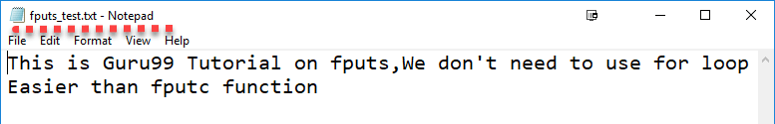
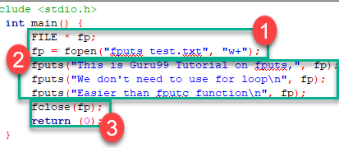
- In the above program, we have created and opened a file called fputs_test.txt in a write mode.
- After we do a write operation using fputs() function by writing three different strings
- Then the file is closed using the fclose function.

fprintf()Function:
#include <stdio.h>
int main() {
FILE *fptr;
fptr = fopen("fprintf_test.txt", "w"); // "w" defines "writing mode"
/* write to file */
fprintf(fptr, "Learning C with Guru99\n");
fclose(fptr);
return 0;
}
OUTPUT:
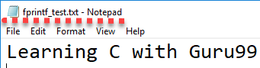
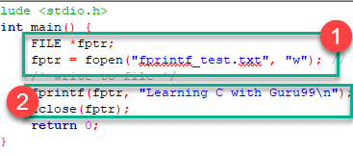
- In the above program we have created and opened a file called fprintf_test.txt in a write mode.
- After a write operation is performed using fprintf() function by writing a string, then the file is closed using the fclose function.

Reading data from a File
There are three different functions dedicated to reading data from a file
- fgetc(file_pointer): It returns the next character from the file pointed to by the file pointer. When the end of the file has been reached, the EOF is sent back.
- fgets(buffer, n, file_pointer): It reads n-1 characters from the file and stores the string in a buffer in which the NULL character '\0' is appended as the last character.
- fscanf(file_pointer, conversion_specifiers, variable_adresses): It is used to parse and analyze data. It reads characters from the file and assigns the input to a list of variable pointers variable_adresses using conversion specifiers. Keep in mind that as with scanf, fscanf stops reading a string when space or newline is encountered.
The following program demonstrates reading from fputs_test.txt file using fgets(),fscanf() and fgetc () functions respectively :
#include <stdio.h>
int main() {
FILE * file_pointer;
char buffer[30], c;

file_pointer = fopen("fprintf_test.txt", "r");
printf("----read a line----\n");
fgets(buffer, 50, file_pointer);
printf("%s\n", buffer);

printf("----read and parse data----\n");
file_pointer = fopen("fprintf_test.txt", "r"); //reset the pointer
char str1[10], str2[2], str3[20], str4[2];
fscanf(file_pointer, "%s %s %s %s", str1, str2, str3, str4);
printf("Read String1 |%s|\n", str1);
printf("Read String2 |%s|\n", str2);
printf("Read String3 |%s|\n", str3);
printf("Read String4 |%s|\n", str4);

printf("----read the entire file----\n");

file_pointer = fopen("fprintf_test.txt", "r"); //reset the pointer
while ((c = getc(file_pointer)) != EOF) printf("%c", c);

fclose(file_pointer);
return 0;
}
Result:
----read a line----
Learning C with Guru99

----read and parse data----
Read String1 |Learning|
Read String2 |C|
Read String3 |with|
Read String4 |Guru99|
----read the entire file----
Learning C with Guru99
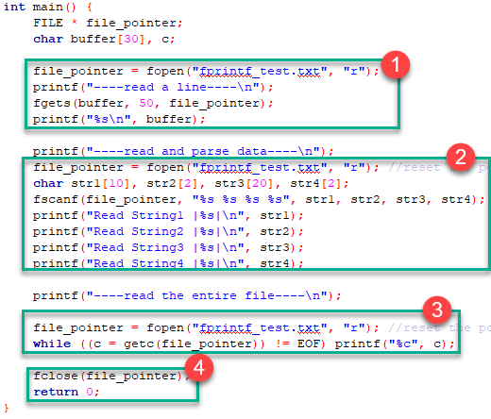
- In the above program, we have opened the file called "fprintf_test.txt" which was previously written using fprintf() function, and it contains "Learning C with Guru99" string. We read it using the fgets() function which reads line by line where the buffer size must be enough to handle the entire line.
- We reopen the file to reset the pointer file to point at the beginning of the file. Create various strings variables to handle each word separately. Print the variables to see their contents. The fscanf() is mainly used to extract and parse data from a file.
- Reopen the file to reset the pointer file to point at the beginning of the file. Read data and print it from the file character by character using getc() function until the EOF statement is encountered
- After performing a reading operation file using different variants, we again closed the file using the fclose function.

Interactive File Read and Write with getc and putc
These are the simplest file operations. Getc stands for get character, and putc stands for put character. These two functions are used to handle only a single character at a time.
Following program demonstrates the file handling functions in 'C' programming:
#include <stdio.h>
int main() {
FILE * fp;
char c;
printf("File Handling\n");
//open a file
fp = fopen("demo.txt", "w");
//writing operation
while ((c = getchar()) != EOF) {
putc(c, fp);
}
//close file
fclose(fp);
printf("Data Entered:\n");
//reading
fp = fopen("demo.txt", "r");
while ((c = getc(fp)) != EOF) {
printf("%c", c);
}
fclose(fp);
return 0;
}
Output:
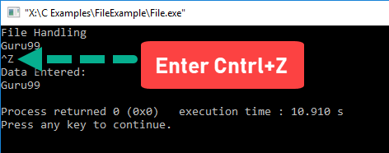
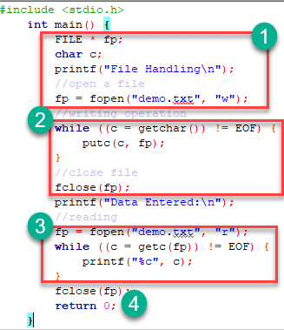
- In the above program we have created and opened a file called demo in a write mode.
- After a write operation is performed, then the file is closed using the fclose function.
- We have again opened a file which now contains data in a reading mode. A while loop will execute until the eof is found. Once the end of file is found the operation will be terminated and data will be displayed using printf function.
- After performing a reading operation file is again closed using the fclose function.
Summary
- A file is a space in a memory where data is stored.
- 'C' programming provides various functions to deal with a file.
- A mechanism of manipulating with the files is called as file management.
- A file must be opened before performing operations on it.
- A file can be opened in a read, write or an append mode.
- Getc and putc functions are used to read and write a single character.
- The function fscanf() permits to read and parse data from a file
- We can read (using the getc function) an entire file by looping to cover all the file until the EOF is encountered
- We can write to a file after creating its name, by using the function fprintf() and it must have the newline character at the end of the string text.

Example 1: Write to a text file
#include <stdio.h>
#include <stdlib.h>

int main()
{
int num;
FILE *fptr;

// use appropriate location if you are using MacOS or Linux
fptr = fopen("C:\\program.txt","w");

if(fptr == NULL)
{
printf("Error!");
exit(1);
}

printf("Enter num: ");
scanf("%d",&num);

fprintf(fptr,"%d",num);
fclose(fptr);

return 0;
}

Example 2: Read from a text file
#include <stdio.h>
#include <stdlib.h>

int main()
{
int num;
FILE *fptr;

if ((fptr = fopen("C:\\program.txt","r")) == NULL){
printf("Error! opening file");

// Program exits if the file pointer returns NULL.
exit(1);
}

fscanf(fptr,"%d", &num);

printf("Value of n=%d", num);
fclose(fptr);

return 0;
}

Example 3: Write to a binary file using fwrite()
#include <stdio.h>
#include <stdlib.h>

struct threeNum
{
int n1, n2, n3;
};

int main()
{
int n;
struct threeNum num;
FILE *fptr;

if ((fptr = fopen("C:\\program.bin","wb")) == NULL){
printf("Error! opening file");

// Program exits if the file pointer returns NULL.
exit(1);
}

for(n = 1; n < 5; ++n)
{
num.n1 = n;
num.n2 = 5*n;
num.n3 = 5*n + 1;
fwrite(&num, sizeof(struct threeNum), 1, fptr);
}
fclose(fptr);

return 0;
}

Reading from a binary file
Function fread() also take 4 arguments similar to the fwrite() function as above.
fread(addressData, sizeData, numbersData, pointerToFile);

Example 4: Read from a binary file using fread()
#include <stdio.h>
#include <stdlib.h>

struct threeNum
{
int n1, n2, n3;
};

int main()
{
int n;
struct threeNum num;
FILE *fptr;

if ((fptr = fopen("C:\\program.bin","rb")) == NULL){
printf("Error! opening file");

// Program exits if the file pointer returns NULL.
exit(1);
}

for(n = 1; n < 5; ++n)
{
fread(&num, sizeof(struct threeNum), 1, fptr);
printf("n1: %d\tn2: %d\tn3: %d", num.n1, num.n2, num.n3);
}
fclose(fptr);

return 0;
}

